**Bright Brightness Shop System Documentation**

Table of Contents

1 System Vision 2

1.1 Client Business Description 2

1.1.1 Who is the client (company)? 2

1.1.2 In which field is the company based? 2

1.1.3 How long have they been in the marketplace? 2

1.1.4 How big is the company? 2

1.1.5 What are their daily work processes? 2

1.1.6 What are the key services or products they offer? 2

1.1.7 Who are their main customers or clients? 2

1.1.8 What are their main business goals or objectives? 2

1.1.9 What challenges do they face in their industry? 2

1.1.10 What are their competitive advantages? 3

1.2 Problem Description 3

1.2.1 Inefficient Inventory Management 3

1.2.2 Limited Customer Management 3

1.2.3 Inadequate E-commerce Presence 3

1.2.4 Lack of Integration Between Systems 4

1.2.5 Limited Reporting and Analytics 4

1.2.6 Impact on Business 4

1.2.7 Objectives 5

1.3 System Capabilities 5

1.4 Business Benefits 6

Tangible Benefits 6

Intangible Benefits 6

1.5 System Functional Decomposition 6

1.6 Project Stakeholders 6

2 System Functional Requirements 6

2.1 Use Case Brief Descriptions 7

2.2 Use case diagrams 8

2.3 Activity diagrams (workflows) 10

2.4 Sequence diagrams 11

3 System object classes 12

4 Evidence of information gathering 13

4.1.1 Interviews 13

4.1.2 Surveys 13

# System Vision

## Client Business Description

### Who is the client (company)?

* The client is Mr. Msane, who operates a medium-sized company in the cleaning products industry.

### In which field is the company based?

* The company is based in the cleaning products field.

### How long have they been in the marketplace?

* The company has several years of experience in the marketplace, indicating a well-established presence.

### How big is the company?

* The company is medium-sized, with multiple branches, indicating a significant scale of operations.

### What are their daily work processes?

* Daily operations include managing cleaning products inventory, processing customer purchases, and ensuring compliance with relevant regulations.

### What are the key services or products they offer?

* The company offers various cleaning products.

### Who are their main customers or clients?

* Their primary customers are individuals and businesses seeking cleaning products.

### What are their main business goals or objectives?

* The main business goals are to efficiently manage cleaning products inventory, provide high-quality customer service in processing purchases, and maintain strict compliance with relevant regulations.

### What challenges do they face in their industry?

* Significant challenges include managing inventory accurately, ensuring timely restocking of cleaning products, maintaining compliance with stringent regulations, and providing excellent customer service in a competitive market.

### What are their competitive advantages?

* Their established market presence, multiple branches, and several years of experience in the industry provide a strong competitive advantage. Additionally, their focus on compliance with regulations and efficient inventory management likely sets them apart from competitors.

## Problem Description

Best Brightness Pongola Shop faces several operational challenges that hinder its efficiency, customer satisfaction, and overall business performance. The primary issues identified include:

### Inefficient Inventory Management

**Current System:** The shop relies on manual processes for tracking inventory, leading to errors and discrepancies in stock levels.

**Problems:**

* **Stockouts and Overstocks:** Frequent stockouts result in lost sales, while overstocks tie up capital and storage space.
* **Inaccurate Stock Data:** Inconsistent and inaccurate inventory records hinder effective decision-making and reorder processes.
* **Manual Updates:** Manual entry and updates are time-consuming and prone to human error.

### Limited Customer Management

**Current System:** Customer information is recorded manually, making it difficult to track purchase history and preferences.

**Problems:**

* **Lack of Personalized Service:** Inability to track customer preferences and purchase history results in a lack of personalized services and targeted promotions.
* **Inefficient Loyalty Programs:** Difficulty in managing loyalty programs and providing incentives to repeat customers.

### Inadequate E-commerce Presence

**Current System:** The shop lacks an online platform, limiting sales to in-store customers only.

**Problems:**

* **Missed Sales Opportunities:** The absence of an online store restricts the shop from tapping into the growing market of online shoppers.
* **Limited Market Reach:** Without an e-commerce platform, the shop’s market reach is confined to the local area.
* **Customer Inconvenience:** Customers prefer the convenience of online shopping and home delivery, which the shop currently cannot offer.

### Lack of Integration Between Systems

**Current System:** Different aspects of the business (inventory, sales, customer management) are managed independently, leading to a lack of integration.

**Problems:**

* **Data Silos:** Disparate systems create data silos, making it difficult to get a holistic view of the business.
* **Inefficient Processes:** Manual data transfer between systems leads to inefficiencies and potential data loss or corruption.
* **Inconsistent Data:** Lack of integration results in inconsistent data across different systems, affecting decision-making.

### Limited Reporting and Analytics

**Current System:** The shop relies on basic reporting capabilities, providing limited insights into business performance.

**Problems:**

* **Inadequate Business Insights:** Limited ability to analyze sales trends, customer behavior, and inventory performance.
* **Reactive Decision-Making:** Inability to generate real-time reports leads to reactive rather than proactive decision-making.
* **Manual Report Generation:** Time-consuming manual process to generate reports, leading to delayed insights.

### Impact on Business

The identified problems have significant impacts on Best Brightness Pongola Shop, including:

* **Reduced Sales and Profitability:** Inefficient inventory management and lack of online presence result in lost sales and reduced profitability.
* **Customer Dissatisfaction:** Limited ability to offer personalized services and the inconvenience of no online shopping option affect customer satisfaction and loyalty.
* **Operational Inefficiencies:** Manual processes and lack of integration lead to operational inefficiencies and higher labor costs.
* **Poor Decision-Making:** Limited reporting and analytics capabilities hinder data-driven decision-making, affecting the shop’s ability to adapt to market changes.

### Objectives

The primary objective is to address these challenges by developing an integrated IT system that enhances inventory management, customer relationship management, and online sales capabilities. This will involve:

* Implementing a real-time inventory management system.
* Developing a customer management module with loyalty program features.
* Creating an e-commerce platform to expand market reach.
* Integrating all systems for seamless data flow and improved operational efficiency.
* Enhancing reporting and analytics capabilities for better business insights.

## System Capabilities

|  |  |
| --- | --- |
| Inefficient Inventory Management | * Real-time tracking of stock levels * Automated reorder alerts when stock falls below threshold * Accurate and centralized inventory data * Streamlined inventory updates through barcode scanning * Historical inventory data analysis |

|  |  |
| --- | --- |
| Limited Customer Management | * Comprehensive customer profiles including purchase history and preferences * Personalized service offerings based on customer data * Efficient management of loyalty programs and rewards * Automated tracking of customer interactions and feedback |

|  |  |
| --- | --- |
| Inadequate E-commerce Presence | * Fully functional online store for product browsing and purchasing * Integration with inventory system for real-time stock updates * Support for multiple payment gateways * Features for order tracking and home delivery |

|  |  |
| --- | --- |
| Lack of Integration Between Systems | * Centralized database for all business operations * Seamless data flow between inventory, sales, and customer management modules * Real-time synchronization of data across different systems |

|  |  |
| --- | --- |
| Limited Reporting and Analytics | * Advanced reporting capabilities for sales, inventory, and customer behavior * Real-time dashboard for key performance indicators (KPIs * Customizable reports for detailed analysis * Data export options for further analysis in external tools |

## Business Benefits

|  |  |
| --- | --- |
| Tangible Benefits | Intangible Benefits |
| Reduced inventory discrepancies | Enhanced brand reputation |
| Improved customer satisfaction through efficient service | Better compliance with regulations |
| Time savings for administrators and customers | Improved data accuracy and security |
| Increased sales through an online presence | Increased customer loyalty through personalized services and loyalty programs |
| Cost savings through automated inventory and sales processes | Better decision-making with advanced reporting and analytics |

## System Functional Decomposition

|  |  |  |
| --- | --- | --- |
| Subsystem | Use Case | Users/Actors |
| User Management | Register Account | Customer, Administrator |
|  | Login/Logout | Customer, Administrator |
| Inventory Management | Upload Product | Administrator |
|  | Update Product Details | Administrator |
|  | Delete Product | Administrator |
|  | View Product List | Customer, Administrator |
| Purchase Processing | Add Product to Cart | Customer |
|  | View Shopping Cart | Customer |
|  | Remove Product from Cart | Customer |
|  | Checkout | Customer |
| Reporting | Generate Sales Report | Administrator |
|  | Generate Inventory Report | Administrator |
|  | View Purchase History | Customer |

## Project Stakeholders

|  |  |
| --- | --- |
| Stakeholder | Role |
| Mr. J Msane | Client, oversees overall project requirements |
| KM Ngcobo | Instructor, provides guidance and evaluation |
| Customers | End-users, interact with the system to purchase products |
| Administrators | Manage inventory and system updates |
| Development Team | Develop and implement the system |
| Sales Team | Interact with the system for sales processes |

# System Functional Requirements

## Use Case Brief Descriptions

|  |  |
| --- | --- |
| Use Case | Description |
| Login | Customers and administrators can log in to the system |
| Browse Products | Customers can view and search for available products |
| Purchase Product | Customers can select products and make purchases |
| Upload Product | Administrators can add new products to the inventory |
| Update Stock Levels | Stock levels are updated in real-time upon purchase |
| Generate Reports | Administrators can generate sales and inventory reports |
| Register Account | Customers and administrators can register for an account |
| View Shopping Cart | Customers can view the contents of their shopping cart |
| Remove Product from Cart | Customers can remove products from their shopping cart |
| Checkout | Customers can proceed to checkout and complete their purchase |
| Generate Sales Report | Administrators can generate reports on sales data |
| Generate Inventory Report | Administrators can generate reports on inventory levels |
| View Purchase History | Customers can view their past purchases and order history |

## Use case diagrams

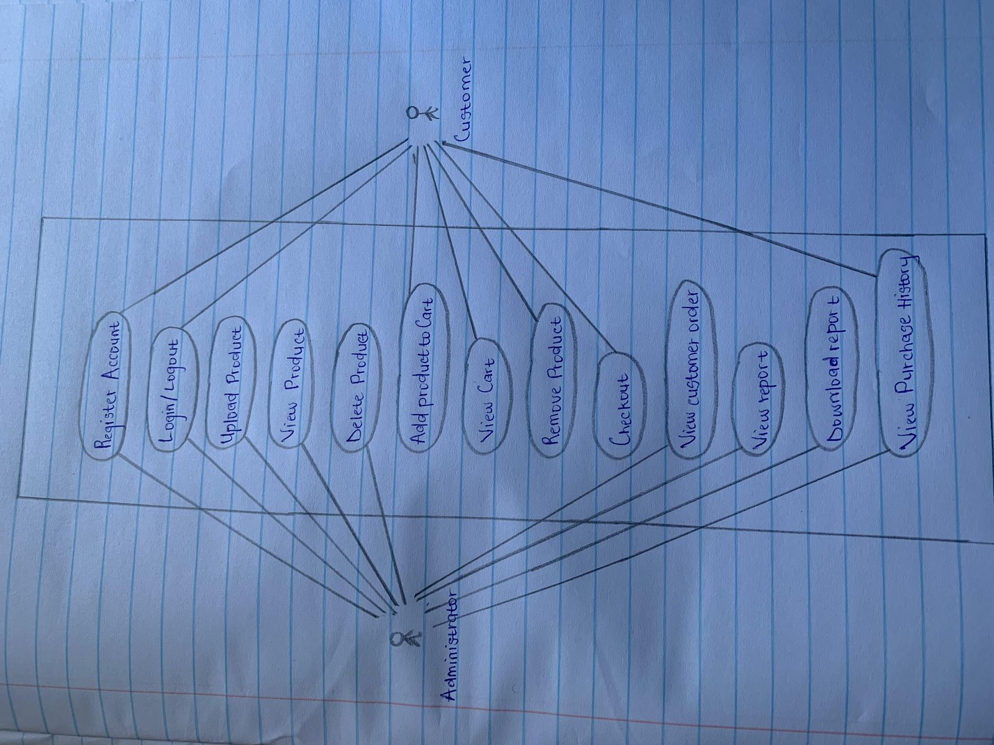

## Activity diagrams (workflows)

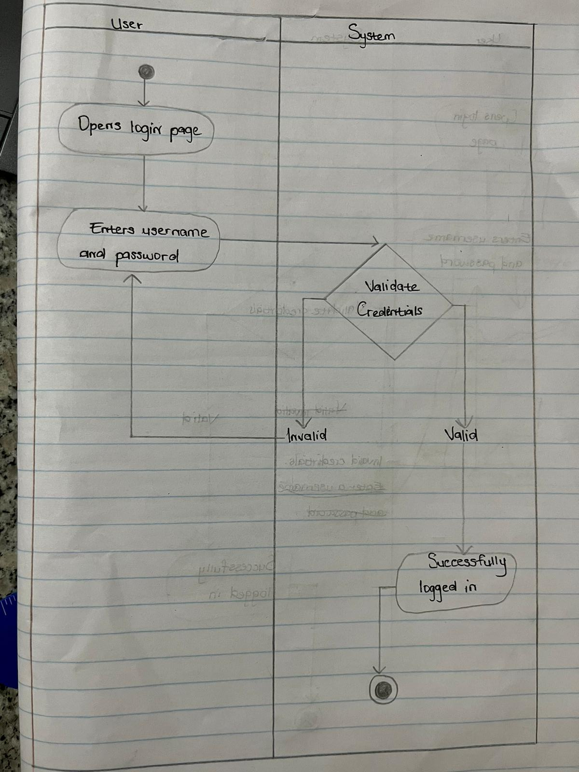

## Sequence diagrams

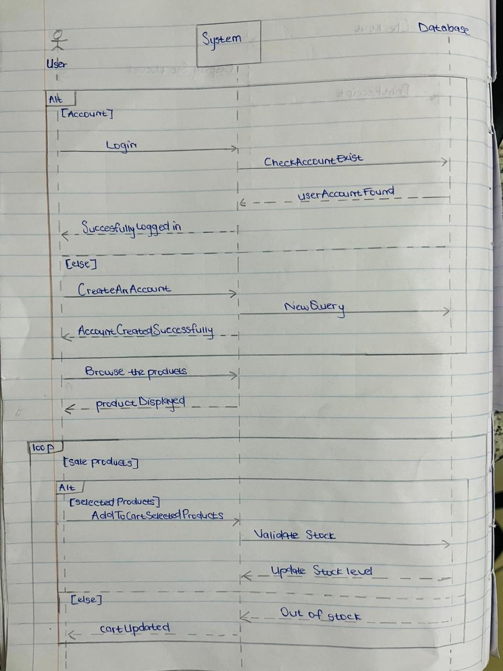

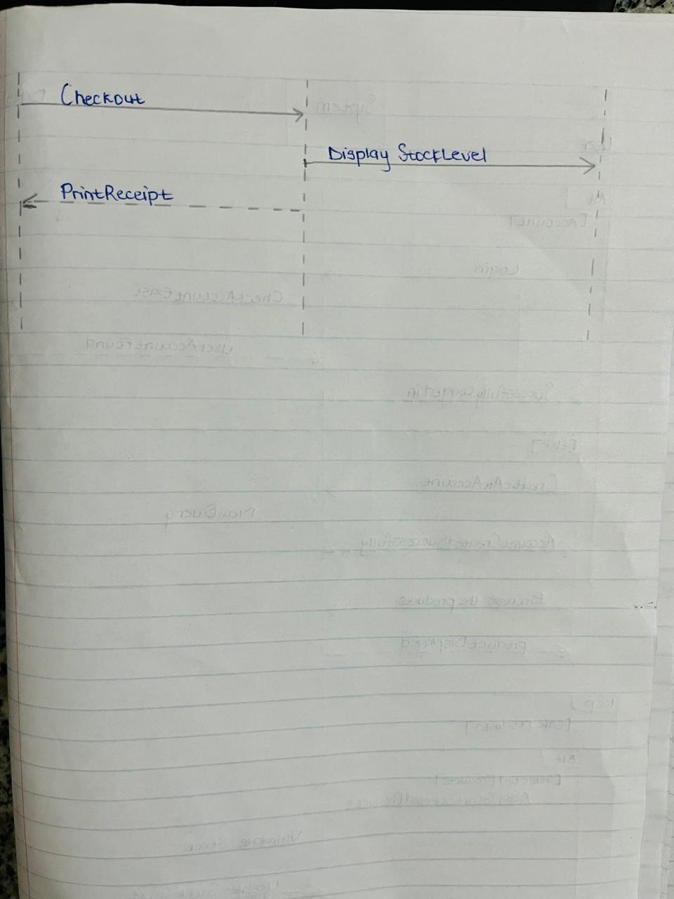

# System object classes

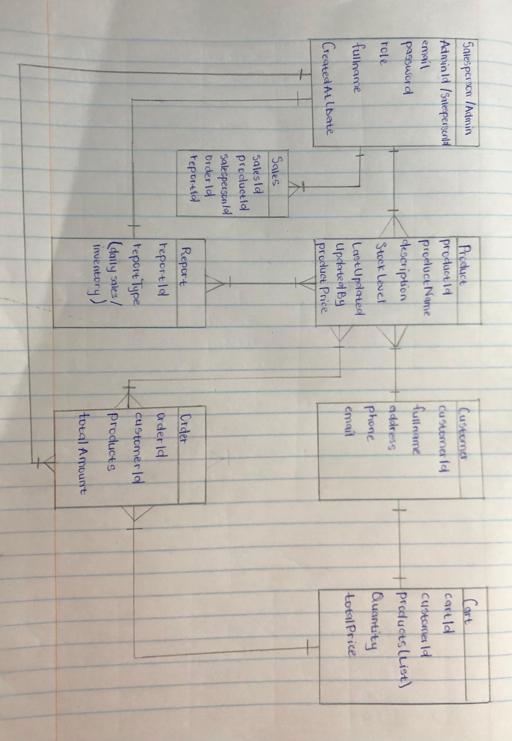

# Evidence of information gathering

Students may use any form of information gathering techniques when investigating system requirements. For each technique adopted and used, evidence to be attached here. For example, if some interviews were conducted with users, attach interview session showing all the details of the interview: date and time, interviewee, list of questions etc… If surveys distributed, attach as sample of a survey used. If company visited with an aim of observing, attach pictures of users in action. If company documents reviewed, attach samples

### **Surveys**

* **Survey Form:** [[Brightness survey (google.com)](https://docs.google.com/forms/d/1awsA8aXa66HDOF-SzMMdEq3HMsF3wf5zwOFbWS-dttY/viewform?edit_requested=true)]
* **Sample Responses:** https://docs.google.com/forms/d/e/1FAIpQLSdjvap4It8HjVVz249eAQeTYelum1xLBtFqE3WZozzFWvR9sA/viewform?usp=sf_link
* **Summary:** Key findings include a need for real-time stock updates and improved customer feedback systems.

**Attachments Checklist:**

* Survey form